Book Recommendation System

A PROJECT REPORT

Submitted By:  
  
[Your Name]  
[Your Enrollment Number]

Under the Guidance of:  
[Supervisor's Name]

November - 2024

Submitted in partial fulfillment of the Degree of  
BACHELOR OF TECHNOLOGY  
IN  
COMPUTER SCIENCE & ENGINEERING

Department of Computer Science & Engineering  
JAYPEE UNIVERSITY OF ENGINEERING & TECHNOLOGY,  
A-B ROAD, RAGHOGARH, DT. GUNA - 473226, M.P., INDIA

# Declaration by the Student

I hereby declare that the work reported in the B. Tech. project entitled as “Book Recommendation System”, in partial fulfillment for the award of degree of Bachelor of Technology, submitted at Jaypee University of Engineering and Technology, Guna, is my original work. As per the best of my knowledge and belief, there is no infringement of intellectual property rights and copyright. In case of any violation, I will solely be responsible.

[Your Name]  
Department of Computer Science and Engineering  
Jaypee University of Engineering & Technology  
Guna, M.P., India

Date: 10-11-2024

# Certificate

This is to certify that the work titled “Book Recommendation System” submitted by [Your Name] in partial fulfillment for the award of degree of Bachelor of Technology of Jaypee University of Engineering & Technology, Guna, has been carried out under my supervision. As per the best of my knowledge, this work has not been submitted partially or wholly to any other University or Institute for any other degree or diploma.

Signature of Supervisor  
[Supervisor’s Name]  
Designation  
Date

# Acknowledgement

I would like to express my sincere gratitude to my project supervisor, [Supervisor’s Name], for their continuous support and guidance throughout this project. I am grateful to the Department of Computer Science & Engineering at Jaypee University for providing the resources necessary to complete this project. Lastly, I would like to thank my family and friends for their encouragement and support.

Signature of Student  
[Your Name]

# Executive Summary

The Book Recommendation System is developed to assist users in discovering books based on their preferences. Leveraging machine learning techniques such as content-based filtering (KNN, Naive Bayes) and collaborative filtering (SVD), the system provides personalized recommendations. Additionally, a time-based module generates weekly trending books, ensuring up-to-date suggestions. The project utilizes Python, Streamlit, and various data science libraries to create a user-friendly interface. This report outlines the project's implementation, methodology, results, and conclusions.

# Table of Contents

1. Introduction

2. Literature Review

3. Requirement Analysis

4. Design and Implementation

5. Results and Discussion

6. Conclusion and Future Work

7. References

Appendices

# Introduction

This chapter introduces the project, its objectives, and scope.

# Literature Review

This chapter covers existing research in the domain of book recommendation systems.

# Requirement Analysis

This chapter outlines the functional and non-functional requirements.

# Design and Implementation

This chapter explains the system architecture and algorithms used.

# Results and Discussion

This chapter evaluates the system’s performance and presents results.

# Conclusion and Future Work

This chapter concludes the report and discusses potential future enhancements.

# References

1. Aggarwal, C. C. (2016). Recommender Systems: The Textbook. Springer.  
2. Goodreads Dataset: https://www.goodreads.com/  
3. Scikit-learn documentation: https://scikit-learn.org/  
4. Streamlit documentation: https://streamlit.io/

# Appendices

Appendix A: Sample Code  
Appendix B: Screenshots of the Interface

Chapter 4

**4.3 Model Implementation**

4**.3.1 collaborative filtering** : In collaborative filtering, cosine similarity is often used to measure the similarity between users based on their ratings or interactions with items. This helps in finding users with similar preferences to make recommendations. Here’s how it works:

1. **Represent User Preferences as Vectors**: Each user’s ratings or interactions with items are represented as a vector. For example, if there are five movies, and User A has rated three of them, User A’s vector might look like [4, 0, 3, 5, 0] where each position corresponds to a movie, and the value represents the rating (0 means no rating).
2. **Calculate Cosine Similarity**: Cosine similarity between two users (say, User A and User B) is calculated by finding the cosine of the angle between their vectors. The formula is:



1. **Interpretation of Cosine Similarity**: The cosine similrity score ranges from -1 to 1, where:
   * A score close to 1 means the users have similar preferences (vectors point in nearly the same direction).
   * A score close to 0 means there’s little similarity between users’ preferences.
   * A negative score (rare in collaborative filtering) indicates opposite preferences.
2. **Use in Recommendations**: Users with high cosine similarity scores are considered "neighbors." The preferences of these similar users are then used to predict ratings for items the target user hasn’t rated, helping generate personalized recommendations.

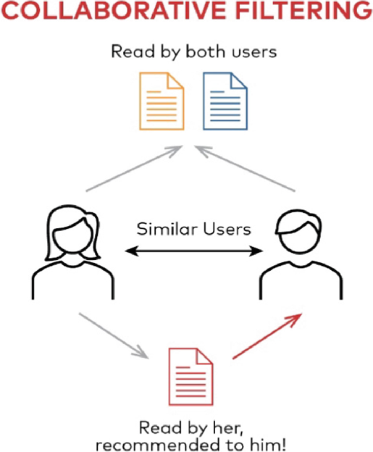

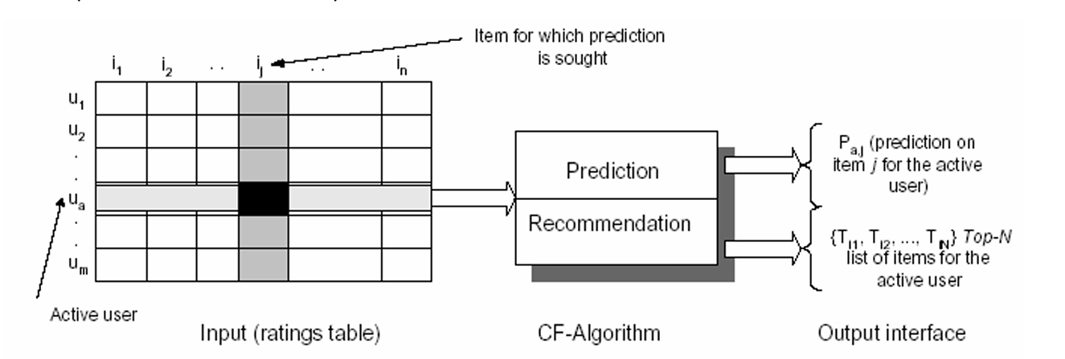

**4.3.2 Content-Based Filtering :** In content-based filtering, Term Frequency-Inverse Document Frequency (TF-IDF) is a popular technique to recommend items based on their features. Here's how it works in this context:

1. **Representing Item Content with TF-IDF**: Content-based filtering focuses on the features of the items, such as keywords describing a movie, product, or article. Each item is treated as a "document," and its keywords are given weights based on their importance using TF-IDF. This technique gives higher weights to terms that are important for the item (frequent in the item description) but not common across all items.
2. **TF-IDF Formula**:
   * **TF (Term Frequency)** measures how often a term appears in a document (e.g., the movie's description).
   * **IDF (Inverse Document Frequency)** measures how unique a term is across all documents.

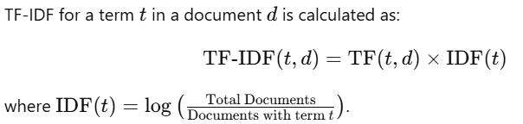

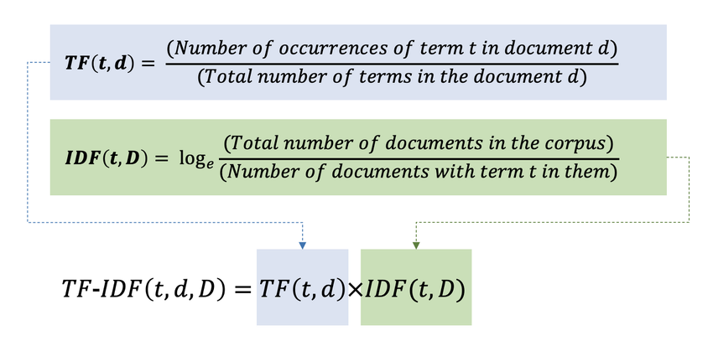

1. **Building Item Profiles**: Each item gets a "profile" vector with its TF-IDF scores. For example, a movie's vector might have high TF-IDF values for keywords like "sci-fi," "space," and "adventure" if those terms are specific and important for the movie.
2. **Matching Items to User Preferences**: A user’s profile is created based on the content of items they’ve previously liked. Then, content-based filtering calculates the similarity between the user’s profile and each item’s TF-IDF vector to recommend new items with similar features.

Using TF-IDF in content-based filtering helps capture the uniqueness and importance of each item's features, making the recommendations more relevant to the user’s known preferences.

**4.4 Technologies Used**

**4.4.1 Streamlit :** Streamlit is an open-source Python framework designed to build interactive, data-driven web applications quickly and easily. It is widely used in data science and machine learning projects due to its simplicity and compatibility with Python libraries, allowing users to create powerful interfaces without needing advanced web development skills.

Streamlit's framework provides a wide array of built-in widgets—such as sliders, checkboxes, file uploaders, and dropdowns—that make it easy to build interactive user interfaces. It also integrates well with visualization libraries like Matplotlib, Plotly, and Altair, enabling dynamic visualizations that update based on user interactions. With minimal code, Streamlit applications can gather user inputs, display data, and even showcase model outputs, making it an ideal choice for rapid prototyping and data exploration.

In this project, we used Streamlit to develop an interactive interface, allowing users to engage with the application seamlessly. This interactive approach enhances user experience, making complex data or model results more accessible and understandable.

**Key Features of Streamlit**

* Python-Based: Write web apps using only Python code, which makes it accessible to data scientists without requiring extensive frontend skills.
* Live Re-rendering: Automatically updates the app in real-time as the underlying data or code changes, making it interactive and dynamic.
* Widgets for Interaction: Provides built-in widgets, like sliders, buttons, checkboxes, and file uploaders, allowing users to interact with the app without HTML or JavaScript.
* Data Visualization: Integrates with popular Python libraries like Matplotlib, Plotly, and Altair to create interactive visualizations.

**4.4.2 Python Library**

**Pandas:** Pandas is a Python library used for working with data sets. it has functions for analyzing, cleaning, exploring, and manipulating data. The name "Pandas" has a reference to both "Panel Data", and "Python Data Analysis" and was created by Wes McKinney in 2008. Pandas allows us to analyze big data and make conclusions based on statistical theories. Pandas can clean messy data sets, and make them readable and relevant. Relevant data is very important in data science.

* A widely-used Python library for data manipulation and analysis.
* Provides data structures like DataFrame for handling and processing structured data.
* Enables data cleaning, filtering, merging, reshaping, and aggregation.
* Ideal for data preprocessing and exploration in data science.
* Supports operations like sorting, re-indexing, iteration, concatenation, data conversion, visualizations, and aggregations.

**NumPy:** NumPy is the fundamental package for scientific computing in Python. It is a Python library that provides a multidimensional array object, various derived objects (such as masked arrays and matrices), and an assortment of routines for fast operations on arrays, including mathematical, logical, shape manipulation, sorting, selecting, I/O, discrete Fourier transforms, basic linear algebra, basic statistical operations, random simulation and much more.

* Stands for "Numerical Python" and is a widely used library.
* Supports large matrices and multi-dimensional data.
* Provides in-built mathematical functions for easy computations.
* Used internally by libraries like TensorFlow for tensor operations.
* Core library for numerical and scientific computing in Python.
* Efficient operations on arrays and matrices, foundational for fast mathematical calculations.
* Many data science libraries are built on top of NumPy for handling large datasets and array manipulation.

**Scikit-learn**: Scikit-learn (Sklearn) is the most useful and robust library for machine learning in Python. It provides a selection of efficient tools for machine learning and statistical modeling including classification, regression, clustering and dimensionality reduction via a consistence interface in Python. This library, which is largely written in Python, is built upon **NumPy, SciPy** and **Matplotlib**.

* A popular open-source Python library for machine learning.
* Supports both supervised and unsupervised algorithms (e.g., linear regression, classification, clustering).
* Works in association with NumPy and SciPy.
* Offers a broad range of algorithms for classification, regression, clustering, and dimensionality reduction.
* Provides tools for data preprocessing, model evaluation, and parameter tuning.
* Versatile for building and evaluating machine learning models.

**Chapter 5**

**5.1 Result**

**/* screenshots**

**Accuracy metries for the rec system */**

**5.2 Conclusion**

**/* summary of findings and project achievements */**

**5.3 Future Enhancements :**

/* improving rec quantity with hybrid modes

Incorporating more datasets to diversify book suggestion */